10 Year Discounted Cash Flow Instructional Guide

This sheet is organized into tabs, each tab containing various information about your property. The sheet is pre-built, meaning that you can enter information on one tab, and the rest of the tabs will automatically be populated.

The 2nd tab, called APOD (Annual Property Operating Data) is the one that you will be concerned with when you are entering your properties information into the sheet. You will see two types of cells- Green cells, and Yellow cells. You want to enter your properties information in the GREEN cells. The yellow cells throughout the sheet will auto-populate once you have done this.

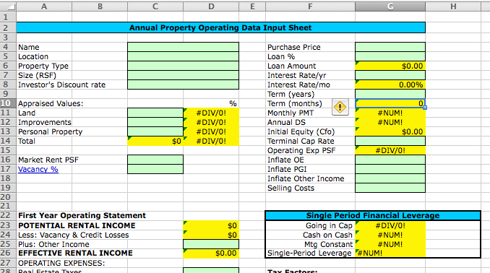

Please DO NOT enter information into the yellow cells!! If you do, the formula will be replaced. If you do happen to accidentally make this mistake, use the “EDIT-> Undo” feature to undo it immediately.

The figures in the Variable Rates tab can be changed to your preference by manually entering the figures of your choosing into each cell. This is the only tab that does not auto populate from the APOD tab.

Please do not hesitate to contact me with any questions that you have. If you want to go more in depth, I also provide a guide to the definitions and descriptions of the terms in this sheet for $10.

